SRM INSTITUTE OF SCIENCE AND TECHNOLOGY
Ramapuram Campus, Bharathi Salai, Ramapuram, Chennai - 600089

FACULTY OF ENGINEERING AND TECHNOLOGY

DEPARTMENT OFCOMPUTER SCIENCE AND ENGINEERING



QUESTIONBANK

Degree & Branch | : B.TECH- CSE
Semester | : III/VI
Sub Code & Subject Name | : 18CSC303J- Database Management Systems
Regulation | : 2018
Academic Year | : 2021-2022

SRM INSTITUTE OF SCIENCE AND TECHNOLOGY
Ramapuram Campus, Bharathi Salai, Ramapuram, Chennai-600089
DEPARTMENT OF COMPUTER SCIENCE AND ENGINEERING

QUESTION BANK

SUBJECT : Subject Code: 18CSC303J- Database Management Systems
SEM/YEAR: VI/III
Course Outcomes
CO1:
CO2:
CO3:
CO4:
CO5:
Q.  No. | Questions | Course Outcome |  |  | Competence  BT Level
1 | A relational database consists of a collection of  - Tables  - Fields  - Records  - Keys | CO2 |  |  | BT1
2 | A ________ in a table represents a relationship among a set of values.  - Column  - Key  - Row  - Entry | CO2 |  |  | BT2
3 | The term attribute refers to a ___________ of a table.  - Record  - Column  - Tuple  - Key | CO2 |  |  | BT1
4 | A ________ is a set of entities of the same type that share the same properties, or attributes.  - Entity set  - Attribute set  - Relation set  - Entity model | CO2 |  |  | BT1
5 | The attribute name could be structured as an attribute consisting of first name, middle initial, and last name. This type of attribute is called  - Simple attribute  - Composite attribute  - Multivalued attribute  - Derived attribute | CO2 |  |  | BT1
6 | The attribute AGE is calculated from DATE_OF_BIRTH. The attribute AGE is  - Single valued  - Multi valued  - Composite  - Derived | CO2 |  |  | BT1
7 | In a relation between the entities the type and condition of the relation should be specified. That is called as______attribute.  - Descriptive  - Derived  - Recursive  - Relative | CO2 |  |  | BT2
8 | An entity in A is associated with at most one entity in B, and an entity in B is associated with at most one entity in A. This is called as  - One-to-many  - One-to-one  - Many-to-many  - Many-to-one | CO2 |  |  | BT3
9 | An entity in A is associated with at most one entity in B. An entity in B, however, can be associated with any number  (zero or more) of entities in A.  - One-to-many  - One-to-one  - Many-to-many  - Many-to-one | CO2 |  |  | BT1
10 | Which of the following can be addressed by enforcing a referential integrity constraint?  - All phone numbers must include the area code  - Certain fields are required (such as the email address, or phone number) before the record is accepted  - Information on the customer must be known before anything can be sold to that customer  - Then entering an order quantity, the user must input a number and not some text (i.e., 12 rather than ‘a dozen’) | CO2 |  |  | BT1
11 | ______ is a special type of integrity constraint that relates two relations & maintains consistency across the relations.  - Entity Integrity Constraints  - Referential Integrity Constraints  - Domain Integrity Constraints  - Domain Constraints | CO2 |  |  | BT1
12 | Which one of the following uniquely identifies the elements in the relation?  - Secondary Key  - Primary key  - Foreign key  - Composite key | CO2 |  |  | BT2
13 | ____________ is preferred method for enforcing data integrity  - Constraints  - Stored Procedure  - Triggers  - Cursors | CO2 |  |  | BT1
14 | Let us consider phone - number, which can take single or several values. Treating phone - number as a _________ permits instructors to have several phone numbers (including zero) associated with them.  - Entity  - Attribute  - Relation  - Value | CO2 |  |  | BT1
15 | Given the basic ER and relational models, which of the following is INCORRECT?  An attribute of an entity can have more than one value  An attribute of an entity can be composite  In a row of a relational table, an attribute can have more than one value  In a row of a relational table, an attribute can have exactly one value or a NULL value | CO2 |  |  | BT1
16 | In E-R diagram generalization is represented by  - Ellipse  - Dashed ellipse  - Rectangle  - Triangle | CO2 |  |  | BT1
17 | What is a relationship called when it is maintained between two entities?  - Unary  - Binary  - Ternary  - Quaternary | CO2 |  |  | BT1
18 | A primary key is combined with a foreign key creates  - Parent-Child relationship between the tables that connect them  - Many to many relationship between the tables that connect them  - Network model between the tables that connect them  - An attribute of an entity can be composite | CO2 |  |  | BT1
19 | There are similarities between the instructor entity set and the secretary entity set in the sense that they have several attributes that are conceptually the same across the two entity sets: namely, the identifier, name, and salary attributes. This process is called  - Commonality  - Specialization  - Generalization  - Similarity | CO2 |  |  | BT1
20 | Consider the employee work-team example, and assume that certain employees participate in more than one work team. A given employee may therefore appear in more than one of the team entity sets that are lower level entity sets of employee. Thus, the generalization is _____________  - Overlapping  - Disjointness  - Uniqueness  - Relational | CO2 |  |  | BT1
21 | The completeness constraint may be one of the following: Total generalization or specialization, Partial generalization or specialization. Which is the default?  - Total  - Partial  - Should be specified  - cannot be determined | CO2 |  |  | BT1
22 | The_____ operation allows the combining of two relations by merging pairs of tuples, one from each relation, into a single tuple.  - Select  - Join  - Union  - Intersection | CO2 |  |  | BT1
23 | The _______operation performs a set union of two “similarly structured” tables  - Union  - Join  - Product  - Intersect | CO2 |  |  | BT1
24 | Which of the following is another name for a weak entity?  - Child  - Owner  - Dominant  - Parent | CO2 |  |  | BT1
25 | The subset of a super key is a candidate key under what condition?  - No proper subset is a super key  - All subsets are super keys  - Subset is a super key  - Each subset is a super key | CO2 |  |  | BT1
26 | In a relational model, relations are termed as  - Tuples.  - Attributes  - Tables.  - Rows. | CO2 |  |  | BT1
27 | In an E-R diagram an entity set is represent by a  - Rectangle.  - Ellipse.  - Diamond box.  - Circle. | CO2 |  |  | BT1
28 | The relational model feature is that there  - Is no need for primary key data.  - Is much more data independence than some other database models.  - Are explicit relationships among records.  - Are tables with many dimensions. | CO2 |  |  | BT1
29 | What is a relationship called when it is maintained between two entities?  - Unary  - Binary  - Ternary  - Quaternary | CO2 |  |  | BT1
30 | Degree of ternary relationship is________________  - 2  - 4  - 5  - 3 | CO2 |  |  | BT1
31 | Let us consider first name, middle initial, and last name as a subparts of name attribute, then Name is a _______________ attribute  - Simple  - Composite  - Single  - Derived | CO2 |  |  | BT1
32 | An entity set which does not have any key attributes is called as a  - Strong entity set  - weak entity set  - partially Strong entity set  - partially weak entity set | CO2 |  |  | BT1
33 | The ______________ relationship may also be referred to as a superclass-subclass relationship.  - Generalization  - Partialization  - Specialization  - Aggregation | CO2 |  |  | BT1
34 | Consider a relation student course details with attributes rno, sname, semester, subjects and rno. be the primary key subjects in this relation can be ________________ attribute  - Single  - Simple  - Composite  - Multivalued | CO2 |  |  | BT1
35 | Which of the following is not valid in case of ER diagram creation.  - Identify all the entities in the system.  - Identify relationships between entities  - Add attributes for entities  - Remove attributes for entities | CO2 |  |  | BT1
36 | ______________ relationship involves the same entity type more than once  - Recursive  - Many to many  - One to many  - Many to one | CO2 |  |  | BT3
37 | __________________ key identifies the tuples uniquely in relation.  - Primary key  - Super key  - Candidate key  - None of these | CO2 |  |  | BT3
38 | Relations obtained from an E-R model will always be in ______________ normal form  - Fourth  - Third  - BCNF  - First | CO2 |  |  | BT2
39 | E-R modeling technique is a:  - Top-down approach  - Bottom-up approach  - Left-right approach  - Right- Left approach | CO2 |  |  | BT2
40 | ______________ is a bottom-up approach in which two lower level entities combine to form a higher level entity.  - Specialization  - Aggregation  - Initialisation  - Generalization | CO2 |  |  | BT2
41 | _____________ key is a candidate key not used for primary key  - Alternate  - Foreign  - Super  - Unique | CO2 |  |  | BT2
42 | Which of the following commands is used to get all the columns in a table?  - #  - *  - %  - @ | CO2 |  |  | BT3
43 | The set of permitted values for each attribute is called its :  - Attribute set  - Attribute range  - Domain  - Group | CO2 |  |  | BT3
44 | ___________ key provides the basic tuple-level addressing mechanism in a relational System  - Unique  - Alternative  - Candidate  - Primary | CO2 |  |  | BT2
45 | The ____________of Primary keys of the related entity sets becomes a Super Key of the relation.  - Union  - Intersection  - Minus  - Aggregation | CO2 |  |  | BT2
46 | Which of the following is not a set operation?  A. Union  B. Intersection  C. Minus  D. Aggregation | CO2 |  |  | BT3
47 | Which of the following is not an aggregation operation?  A. Max  B. Min  C. Minus  D. Sum | CO2 |  |  | BT3
48 | In E-R diagram generalization is represented by  A. Ellipse  B. Dashed ellipse  C. Rectangle  D. Triangle | CO2 |  |  | BT2
49 | In an E-R, Y is the dominant entity and X is a subordinate entity. Then which of the following is incorrect?  - operationally, If Y is deleted, so is X  - X existence is dependent on Y  - operationally, if X is deleted, so is Y  - operationally, if X is deleted, Y remains the same | CO2 |  |  | BT2
50 | ---------- denote derived attributes.  A. Double ellipse  B. Dashed ellipse  C. Squared ellipse  D. Ellipse with attribute name underlined | CO2 |  |  | BT3
PART B (4 Marks)
1. | What is the difference between a database schema and a database state?  The following points explain the main differences between database and schema:  - The fundamental difference between them is that the database is an organized collection of interrelated data or information about the considered object. In contrast, the schema is a logical representation or description of an entire database.  - Once we declare a database schema, we must not change it often as it would disturb the organization of data stored in the database. In contrast, we can update the database regularly.  - The database is a collection of schema, records, and constraints for the tables. On the other hand, a schema contains the structure of tables, attributes, their types, constraints, and how they relate to other tables.  - The DDL statement is used to generate and modify the schema. On the other hand, DML statements are used to create and modify the data inside the database.  - Each database uses the memory to store the data, whereas the schema can use a logical structure to store data.  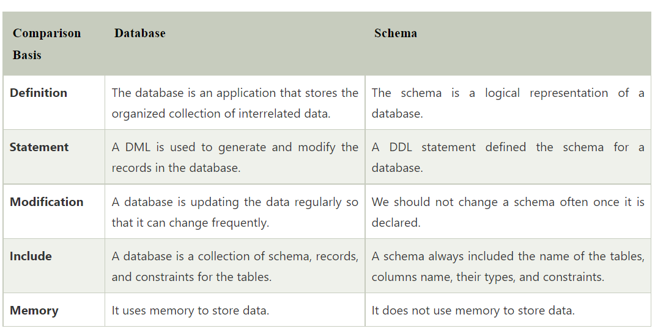 |  | CO2 |  |  | BT1
2 | What is an entity type? What is an entity set? Explain the differences among an entity, an entity type, and an entity set.  The entity type refers to the collection of entity that share a common definition.  Entity set is the set of entities of the same type that share the same attributes.  E.g. Set of all people who are customer at a particular bank can be defined as the entity customer, while, Entity set of entities of the same entity type.  Entity: It is something which has real existence.  Entity Type: It is collection of entity having common attribute. Also each entity type in a database is described by a name and a list of attribute. So we may say a table is an entity type  Entity SET: It is a set of entities of same entity type. So a set of one or more entities of an Entity type is an Entity Set. |  | CO2 |  |  | BT1
3 | When is the concept of a weak entity used in data modeling? Define the terms owner entity type, weak entity type, identifying relationship type, and partial key.  Concept of weak entity types is used in data modeling when we want to specify a new entity type similar to the one we already have, but we want this new entity type to have specific attributes and to be able to participate in specific relationships.  If the newly made entity type doesn't have key attributes, it is called weak entity type and it needs to be related to a strong entity type (directly or indirectly) that has: key attributes of its own.  Owner (or identifying) entity type is a title for entity type that identifies weak entity types related to it. Weak entity types include one of their attributes when combining with owner entity type.  Weak entity type is an entity type that does not have key attributes of its own.  Identifying relationship type is a title for relationship type that relates one weaker entity type to one owner entity type. In this relationship type, weak entity has a total participation constraint, meaning it cannot exist without its owner entity type that identifies it.  Partial key (or discriminator) is an attribute or set of attributes of a weak entity type that distinguishes weak entities related to the same owner entity type. |  | CO2 |  |  | BT1
4 | Can an identifying relationship of a weak entity type be of a degree greater than two? Give examples to illustrate your answer.  An identifying relationship of a weak entity type can be of a degree greater than two. An example of this would be the ternary relationship of Supply. Supply is a weak entity type that has three identifying relationships. |  | CO2 |  |  | BT2
5 | Draw an ER schema diagram for the COMPANY database.  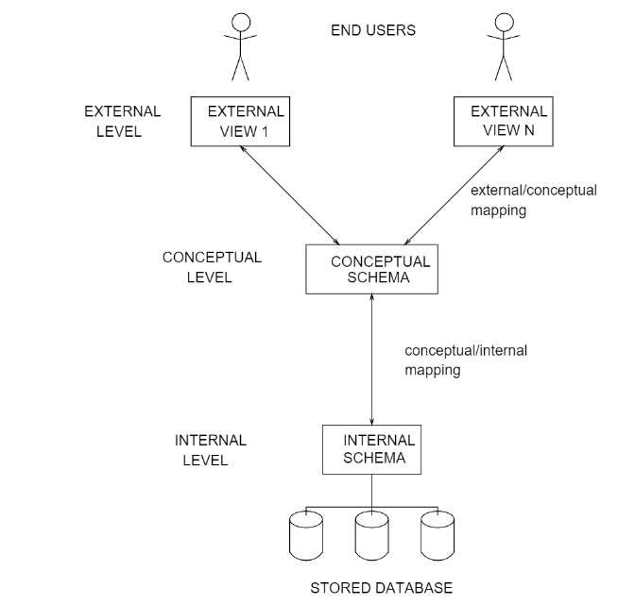  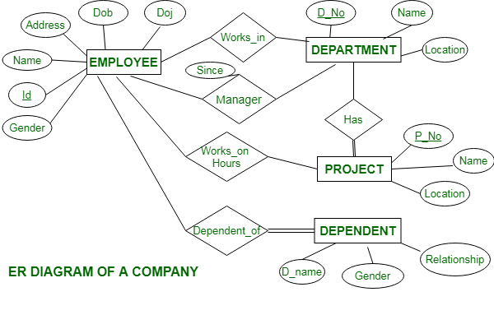 |  | CO2 |  |  | BT1
6 | Describe the two alternatives for specifying structural constraints on relationship types. What are the advantages and disadvantages of each?  The two alternatives for specifying structural constraints on relationship types are :  - Cardinality ratio and  - Participation constraint  Cardinality ratio  Cardinality ratio is a simple way of specifying designs, it is specifies the maximum number of relationship a body/entity can be engaged in.  Advantage of Cardinality ratio  It is used to simply complex designs  Disadvantage of cardinality ratio  No specific number can be said to be maximum  Participation constraint  Participation constraint specifies the dependency of an entity on another entity based on the relationships existing between the entities  Advantage of participation constraint  It specifies the minimum number of relationship an entity can engage  It shows the dependency of an entity on another  Disadvantage  It is a more expensive alternative  Hence we can conclude that The two alternatives for specifying structural constraints on relationship types are : Cardinality ratio and  and Participation constraint |  | CO2 |  |  | BT2
7 | Discuss the two main types of constraints on specializations and generalizations.  Specialization: constraints are generally used to provide limitations on data which can be used in table for database. Not null, unique are two constraints used in specialization.  Generalization: it is a bottom up approach and in this constraints are used to create limitations in data. Check and default are two constraints used to limit data in generalization. |  | CO2 |  |  | BT2
8 | What is the difference between specialization and generalization? Why do we not display this difference in schema diagrams?  Generalization is process of extracting common characteristics from two or more classes and combining them into a generalized superclass.  A Specialization is the reverse process of Generalization means creating new sub classes from an existing class. |  | CO2 |  |  | BT1
9 | Design a database to keep track of information for an art museum. Assume that the following requirements were collected:  ■ The museum has a collection of ART_OBJECTS. Each ART_OBJECT has a unique Id no, an Artist (if known), a Year (when it was created, if known), a Title, and a Description. The art objects are categorized in several ways, as discussed below.  ■ ART_OBJECTS are categorized based on their type. There are three main types: PAINTING, SCULPTURE, and STATUE, plus another type called OTHER to accommodate objects that do not fall into one of the three main types. |  | CO2 |  |  | BT1
10 | Discuss about Entity Types, Entity Sets, Keys, and Value Sets with examples.  The entity type is a collection of the entity having similar attributes. In the above Student table example, we have each row as an entity and they are having common attributes i.e. each row has its own value for attributes Roll no, Age, Student name and Mobile no. So, we can define the above STUDENT table as an entity type because it is a collection of entities having the same attributes. So, an entity type in an ER diagram is defined by a name (here, STUDENT) and a set of attributes (here, roll no, Student name, Age, Mobile no).  Types of Entity type  - Strong Entity Type  - Weak Entity Type  Strong Entity Type: Strong entity are those entity types which has a key attribute. The primary key helps in identifying each entity uniquely. It is represented by a rectangle.  Weak Entity Type: Weak entity type doesn't have a key attribute. Weak entity type can't be identified on its own. It depends upon some other strong entity for its distinct identity.  Entity Set is a collection of entities of the same entity type. In the above example of STUDENT entity type, a collection of entities from the Student entity type would form an entity set. We can say that entity type is a superset of the entity set as all the entities are included in the entity type.  A key could either be a combination of more than one attribute (or columns) or just a single attribute. The main motive of this is to give each record a unique identity.  There are broadly seven types of keys in DBMS:  - Primary Key  - Candidate Key  - Super Key  - Foreign Key  - Composite Key  - Alternate Key  - Unique Key |  | CO2 |  |  | BT2
11 | What are the Constraints on Binary Relationship Types?  The participation constraint specifies whether the existence of an entity depends on its being related to another entity via the relationship type. This constraint specifies the minimum number of relationship instances that each entity can participate in, and is sometimes called the minimum cardinality constraint. There are two types of participation constraints—total and partial—that we illustrate by example. If a company policy states that every employee must work for a department, then an employee entity can exist only if it participates in at least one WORKS_FOR relationship instance. Thus, the participation of EMPLOYEE in WORKS_FOR is called total participation, meaning that every entity in the total set of employee entities must be related to a department entity via WORKS_FOR. Total participation is also called existence dependency. We do not expect every employee to manage a department, so the participation of EMPLOYEE in the MANAGES relationship type is partial, meaning that some or part of the set of employee entities are related to some department entity via MANAGES, but not necessarily all. |  | CO2 |  |  | BT2
12 | Define Weak entity and its types.  - A weak entity is an entity set that does not have sufficient attributes for Unique Identification of its records.  Example 1 – A loan entity cannot be created for a customer if the customer doesn’t exist  Example 2 – A dependents list entity cannot be created if the employee doesn’t exist  - Simply a weak entity is nothing but an entity that does not have a primary key attribute  - It contains a partial key called a discriminator which helps in identifying a group of entities from the entity set  - A discriminator is represented by underlining with a dashed line  Representation  - A double rectangle is used for representing a weak entity set  - The double diamond symbol is used for representing the relationship between a strong entity and a weak entity which is known as identifying relationship |  | CO2 |  |  | BT2
13 | Give a Summary of the notation for ER diagrams with neat diagram representation  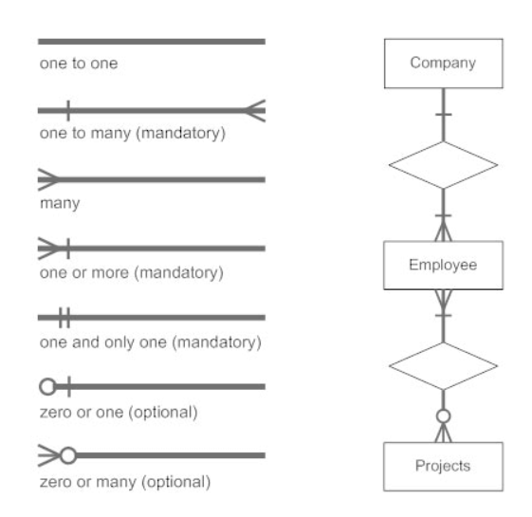  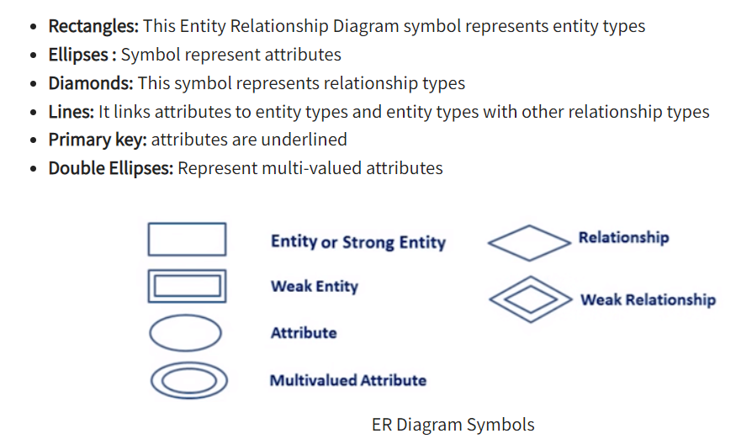 |  | CO2 |  |  | BT2
14 | Explain about the Constraints on Ternary (or Higher-Degree) Relationships.  There are two notations for specifying structural constraints on n-ary relationships, and they specify different constraints. They should thus both be used if it is important to fully specify the structural constraints on a ternary or higher-degree relationship. The first notation is based on the cardinality ratio notation of binary relationships. The second notation is based on the (min, max) notation. A (min, max) on a participation here specifies that each entity is related to at least min and at most max relationship instances in the relation-ship set. These constraints have no bearing on determining the key of an n-ary relationship, where n > 2, but specify a different type of constraint that places restrictions on how many relationship instances each entity can participate in. |  | CO2 |  |  | BT2
15 | Explain the difference between an attribute and a value set.  The difference between an attribute and a value set is:  An attribute holds values, while a value set are those things which are contained in a class.  An attribute is the name that is given to the property of a class. On the other hand, a value set are those things that are used to represent an object in a given class.  For example, an attribute can have the name "Apples" and can hold the value of "abc" while the value set are those things that can be attributed to a class.  An attribute is a characteristic.  For example, Attributes in the invoice can be price, number, date etc.  A value set specifies the set of values that may be assigned to that attribute for each individual entry. |  | CO2 |  |  | BT2
PART C (12 Marks)
1 | Discuss the role of a high-level data model in the database design process. |  | CO2 |  |  | BT2
2 | Define the following terms: entity, attribute, attribute value, relationship instance, composite attribute, multivalued attribute, derived attribute, complex attribute, key attribute, and value set (domain). |  | CO2 |  |  | BT2
3 | When is the concept of a weak entity used in data modeling? Define the terms owner entity type, weak entity type, identifying relationship type, and partial key. |  | CO2 |  |  | BT2
4 | A database is being constructed to keep track of the teams and games of a sports league. A team has a number of players, not all of whom participate in each game. It is desired to keep track of the players participating in each game for each team, the positions they played in that game, and the result of the game. Design an ER schema diagram for this application, stating any assumptions you make. Choose your favorite sport (e.g., soccer, baseball, football). |  | CO2 |  |  | BT2
5 | Discuss the main categories of data models. What are the basic differences  between the relational model, the object model, and the XML model? |  |  | CO2 |  | BT2
6 | Discuss the naming conventions used for ER schema diagrams. |  | CO2 |  |  | BT2
7 | Explain in detail about the Conversion of ER to Relational Table with relevant examples. |  | CO2 |  |  | BT2
8 | Discuss in detail about Key Constraints and Constraints on NULL Values with examples. |  | CO2 |  |  | BT2

